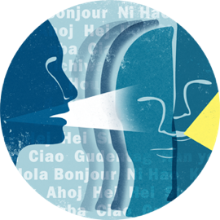 | University of Kentucky  Linguistics Colloquium

Some limits on social speech perception and what they might mean -or- I’ve had a lot of null results and I think I finally learned something

Every time we open our mouths to speak or raise our hands to sign we inevitably reveal not only what we are trying to communicate but who we are, where we come from, and myriad other social cues. Sometimes, correctly expecting these cues can enhance our ability to understand one another (McGowan 2015). Sometimes, these expectations can alter our high-level, social judgments of a talker without always shifting our low-level phonetic perceptions of their voice (McGowan & Babel 2020). I will present a number of results this research area, including a pair of my own null results that are jaw-dropping for how incredibly null they are, as framing for a replication and extension of Strand & Johnson (1996) I have recently completed in collaboration with MALTT alumnus, Kyler Laycock. Strand & Johnson found that showing listeners a prototypical male or female face can shift listeners' perceptual boundary along a [ʃ]-[s] fricative continuum. This is often described (although, importantly, not by Strand or Johnson) as visual social information ‘overriding’ the acoustic information. We have replicated this result but, by manipulating the belief conditions and congruence of social information in the voice and face, unraveled, we believe, some mysteries about the limits of visually-presented social speech perception. When social information from the face and voice are incongruous, for example, the voice wins. Not only does this make most of my null results make sense, but also makes available a number of new, interesting, questions about social speech perception, grammar, and the extent to which it matters whether listener expectations are at, or below, the level of conscious awareness.

Dr. Kevin McGowan  University of Kentucky | 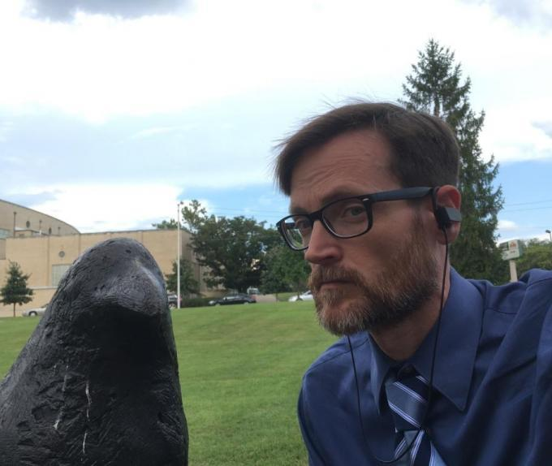
September 22 @ 1 PM
Cornerstone Esports Theater

